 | 

Multi-language dictionary “MultiLex” for

NOKIA Communicator

Last modified on the 21-st of March, 2002.

About the program

“MultiLex” is a multi-language dictionary for NOKIA Communicator.
Advantages of the program are:
- Great number of word entries
- Low memory consumption
- The possibility to install several language pairs
- Convenient interface and color formatting of word entries

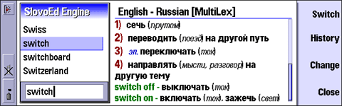

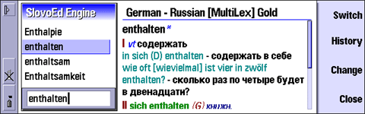

- Search history (last words that you searched), you can see any word from the history again at any time
- Transcription support.

High data compression ratio for dictionaries with a high access rate is available due to special technology developed by Paragon Software (SHDD) (http://www.penreader.com).

Information about all dictionaries that we develop is available at www.penreader.com/Nokia_9210/SlovoEd.html.

Demo-version limitations:
The more you use an unregistered dictionary, the more you see a message about its registration procedure.

Installation

Note:

- Don’t forget to perform backup of all your data before unstallation of a new program (including “MultiLex”)! It will help you to avoid casual data loss.

- If you are going to install “MultiLex”, you should remember that the program will be installed on the device and all the dictionaries will be installed on a memory card. Thus if the memory card is not inserted into your device, you will see an error message during the installation process and the installation will be interrupted.

To install “MultiLex” on your device connect your communicator with the desktop computer. You can establish connection using the PC Suite program, which is supplied with Nokia 9210 on CD-ROM. When the connection is established, do the following:

- Copy the SlovoEd_XXXX.sis file (XXXX is abbreviated name of the dictionary you are going to install) from the desktop computer to any folder of your communicator.

- Start the SlovoEd_XXXX.sis file on your device.

- Follow the instructions of the installation program.

You can install the “MultiLex” program with several dictionaries. To do that you should copy all the dictionary files to your device and start them one after another. Then you will be able to use several dictionaries simultaneously (for example, Spanish-English and English-German) and change the dictionaries by the Change dictionary operation.

Using “MultiLex”

Attention! Nokia 9210 fonts don’t contain Russian letters. If you are going to use Russian letters in “MultiLex”, you should install a localization system that will deliver Russian letters on your device.

The “MultiLex” icon is placed in the Extras panel.

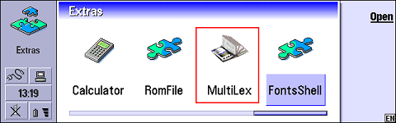

After starting the “MultiLex” program the screen of your communicator will appear as follows:

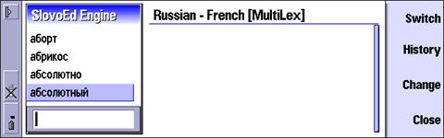

There is an edit field at the bottom of the SlovoEd Engine window. You can type there a word that you want to translate. You can enter words in the edit field using NOKIA keyboard or using the “Paste” operation if you have copied anything to the Clipboard.
To get translation of the word you should press Enter. If the dictionary contains the word that you entered, you will see translation of the word in the translation field.
You can look through the list of words contained in the dictionary by pressing the Up/Down arrow on the keyboard.

The elements of the program interface are shown in the picture below:

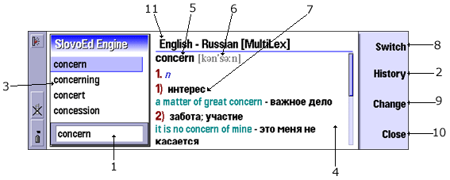
- Edit field.
- History.
- List of words available in the dictionary.
- Translation field.
- Found word.
- Transcription.
- Translation of the word entry. All the meanings of translation are numbered.
- The “Switch dictionary” button. This button switches the dictionary to the pair dictionary.
- The “Change dictionary” button. You can choose any dictionary from the list of the installed dictionaries.
- The “Close SlovoEd” button.
- Title of the active dictionary.

The “SlovoEd” menu includes four sections:
You can tune “MultiLex” using the File menu. You can change font size and width of the translation field.

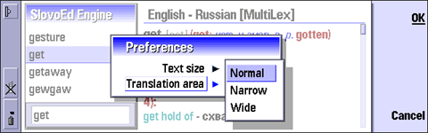

The Edit menu performs Copy, Paste, Select and Clear operations with text in the edit field.

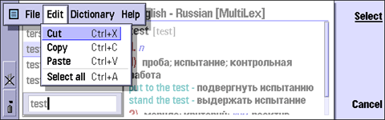

The Dictionary menu allows to switch the current dictionary to the pair one. Also you can choose one of the installed dictionaries using the Change dictionary item.

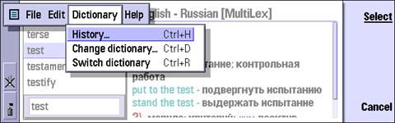

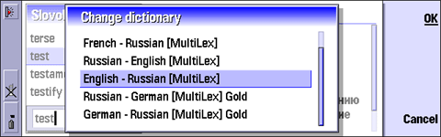

The Help menu informs you about the current dictionary and gives the possibility to register your dictionary.

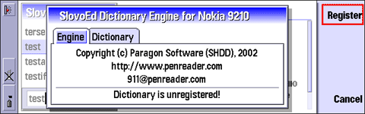

You can get translation of any word from the translation field. If you want to get translation of a word from the translation field, set cursor on it or select that word and press Enter. The dictionary will show you translation of that word.

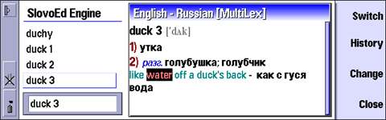
There are some shortcuts to act quickly in the dictionary:

Tab | Change the window
Ctrl + R | Switch dictionary
Ctrl + H | Open history
Ctrl + D | Change dictinary
Ctrl + P | Open preferences
Ctrl + E | Close “MultiLex”
Ctrl + Shift + A | Open the “About” dialog
Enter | Translate a word
Ctrl + BackSpace | Clear edit field
Escape | Clear edit field
Ctrl + Left arrow | Translate previous word from history
Ctrl + Right arrow | Translate next word from history

Support and updates service

If you have any questions concerning “MultiLex” and RUNOkia programs contact technical support service of Paragon Software (SHDD):
Tel: (095) 408-61-79, 408-76-77
(Operation time of technical support line is 11.30 - 19.00 Moscow time)∗
Web: http://www.penreader.com
911@penreader.com

MultiLex^{ТМ} is the registered trade mark of the MediaLingua company. All rights reserved. Any unapproved copying is prohobited by the law.
ZAO «MediaLingua», 115446, Moscow, Kolomensky St. 1а , tel. (095) 115-9752, fax (095) 115-9752, http://www.medialingua.ru, multilex@medialingua.ru

How to buy SlovoEd dictionaries for NOKIA 9210

To register your copy of “MultiLex“ dictionaries you should buy registration number. You can find detailed information about buying procedure on our web site:
http://www.penreader.com/PalmOS/SlovoEd/articles/Shopping_area_for_SlovoEd.html
Please contact us if you have any problem with placing your on-line order:
911@penreader.com

Dear customers!
We will be glad to get your suggestions and comments that will help us to increase our programs quality.
Thanks you for your comments and suggestions!

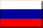
© ZAO «MediaLingua», 1996-2002
© Paragon Software (Smart Handheld Devices Division), Dolgoprudny, Moscow region, Russia
21.03.2002

We recommend you to use localization system named RUNOkia by Paragon Software. Information about RUNOkia is available at the web site: www.penreader.com/Nokia_9210/RUNOkia.html.
 When calling from outside Russia, please consider time shifts: Moscow is 11 hours ahead of San-Jose, 8 hours ahead of New York, 3 hours ahead of London, 2 hours ahead of Munich and Paris, 6 hours behind Tokyo. Moscow office operation hours are from 11.30 till 19.00 by Moscow local time.

